PIZZA SALES SQL QUERIES.

A) KPI’s

1) Total Revenue : The total amount that was made from the sales of the pizza.

Select Sum(total_price) AS Total_Revenue from [dbo].[pizza_sales excel file]

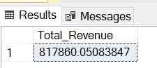

2) Average Order value: This will be calculated by the average amount spent per order, which will be the total revenue divided by the total number of orders( distinct order_id).

Select Sum(total_price) / Count(Distinct Order_id) As Avg_order_value from [dbo].[pizza_sales excel file]

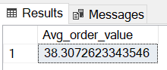

3) Total pizza sold: The sum of all the quantities sold.

Select Sum(quantity) As Total_pizza_sold from [dbo].[pizza_sales excel file]

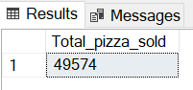

4) Total Orders: The total number of orders placed ( total distinct order_id).

Select Count(distinct order_id) AS Total_Orders from [dbo].[pizza_sales excel file]

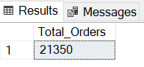

5) Average pizza per order: This will be the total number of pizza sold divided by the total number of orders.

Select Cast(Sum(quantity)as Decimal(8,2)) / Cast(Count(distinct order_id)as Decimal (8,2)) As Avg_pizza_per_order from [dbo].[pizza_sales excel file]

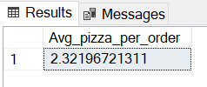

CHARTS REQUIREMENTS.

1) Daily trend for total orders: This chart will display the daily trend for daily orders over a specific time.

Select DATENAME(DW, order_date) as Order_day, Count(distinct Order_id) as Total_orders from [dbo].[pizza_sales excel file]

Group By DATENAME(DW, order_date)

Order by Total_orders DESC

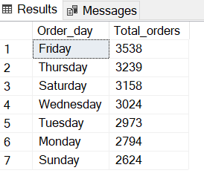

2) Monthly Trend for total orders: Thischart will show the total orders received for different months.

Select DATENAME(MONTH, order_date) as Month_name, Count(distinct Order_id) as Total_orders from [dbo].[pizza_sales excel file]

Group By DATENAME(Month, order_date)

Order by Total_orders DESC

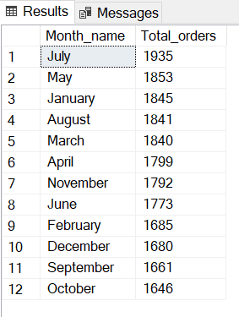

3) Percentage of sales by pizza category (PSBPC): Create a pie chart to show the different pizza categories and its distribution towards total sales.

Select pizza_category ,Sum(total_price) As total_sales, Sum(total_price) * 100 / (select sum(total_price) from [dbo].[pizza_sales excel file]) as PSBPC from [dbo].[pizza_sales excel file]

Group by pizza_category

N:B - We have also calculated total sales of pizza by category.

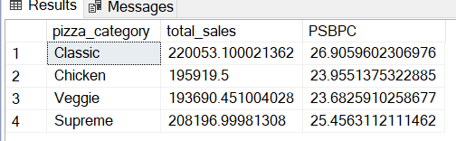

4) Percentage of sales by pizza size: This is the %age of sales associated with the different pizza sizes. This will help us understand customers preferred size and how it relates to total revenue.

Select pizza_size ,Sum(total_price) As total_sales, Sum(total_price) * 100 / (select sum(total_price) from [dbo].[pizza_sales excel file]) as PSBPS from [dbo].[pizza_sales excel file]

Group by pizza_size

Order by PSBPS DESC

